THE UNDERWORLD
When Egyptians died they were made into mummies and then they had to make a long and difficult journey through the Underworld. They wanted to live for ever in the company of Osiris, King of the Dead, in a pleasant land where they harvested giant grain but otherwise did no hard work at all.
But the mummy had a long way to go and many dangers lurked in the unknown: a giant serpent as long as life itself; a monkey with a trap; people to chop off its head, tie it up or drown it in a pool; a furnace as hot as hell; and a very hungry crocodile. But the most frightening test of all came at the end of the journey: the scales, where the dead person had to reveal if he or she had always told the truth, and Ammit, a terrifying monster, was waiting to gobble up their hearts. How would you have managed on the journey through the Underworld?
Colour the picture of Anubis, god of embalming, weighing the heart of the dead person against the feather of truth.
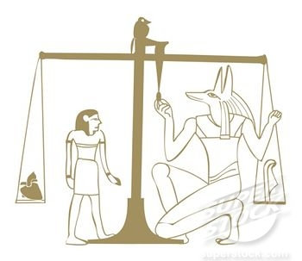
Now, create a flowchart showing the journey of the soul to the fields of Yura…
Example:

Person dies → → → Fields of Yura

HINT: There are ten stages

UNWRAPPING THE MUMMY OF WAH:
Next came more bandages stained with resin and a large blue collar of blue faience beads and bracelets on the wrist and ankles. The skeleton inside the last wrappings showed that Wah was about 30 years old when he died.
When the archaeologists removed the sheets they found that the embalmers had poured a thick layer of resin over the body to preserve it. It was hard and dry.
The Mummy of Wah was wrapped in a red shawl.

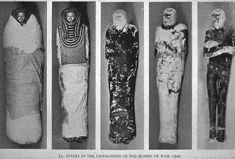

Under more sheets and bandages, four necklaces appeared. One was made of silver, the second of gold, the third of blue faience (glazed earthenware), and the fourth of mixed semi-precious stones.
Underneath the shawl were sheets made of linen. The face was protected by a gilded mask and with a blue and green wig. The necklace was red, blue and green.

